1. **What is elasticsearch**?
2. **Answer**: It is open source Analytics & full text search engine.  
   
3. **Why to use:** Used to enable search functionalities for application.
4. **For Example**: On your blog or webshop, you want users to be able to search for various kinds of data.
   1. It could be blog posts, products, categories or anything you want.  
      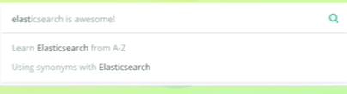
5. 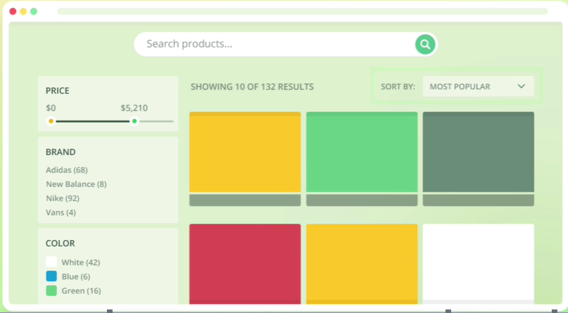  
   We could make complex search functionality with Elasticsearch similar to what you see on Google.
   1. This could include
      1. Auto-completion.
      2. Correcting typos.
      3. Highlighting matches.
      4. Handling Synonyms.
      5. Adjusting relevance etc.
6. Suppose we want to implement searching for a webshop.   
   Besides searching through product names and other full-text fields, we might want to take a number of factors into account when **sorting** the results.  
   If the products have ratings, we probably want to boost the relevance of highly rated products.  
   We also might want to allow users to **filter results**, such as by price range, brand, size, color etc and to sort by price or relevance for instance.
7. Basically, Elasticsearch can do everything you will need to build a powerful search engine and you will learn all of these in this course.
8. 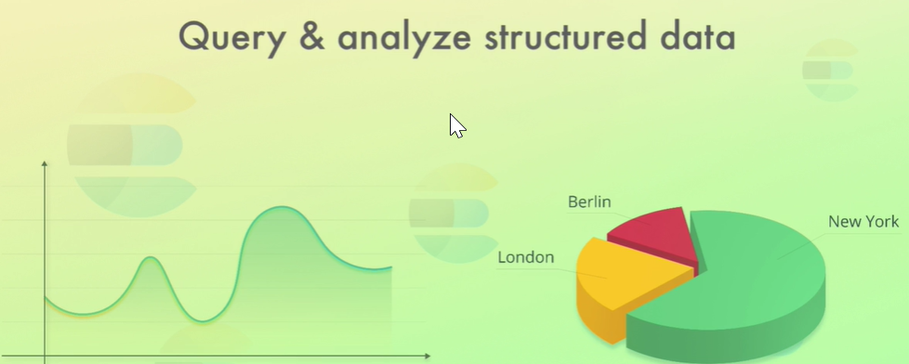Full-text search is not the only thing Elasticsearch can do though.  
   You can do the **followings**:
   1. Querying Structured Data such as numbers.
   2. Aggregate Data.
   3. Writing queries that aggregate data and use the results for making **pie charts, Line Chart**.
9. 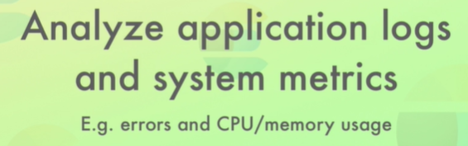  
   This is not only a business intelligence solution but you can get valuable info out of the data that you store within Elasticsearch.  
   An example would be
   1. To store logs from application and various server system metrics then analyze these, perhaps with alerting set up.
   2. To keep track of the number of errors for a web application or the CPU and memory usage of servers and show that on a line chart for instance.

This is referred to as **“Application Performance Management” (APM)**.



1. 